# User Documentation for Java Financial Accounting

## Introduction

This documentation provides a guide to using the Text User Interface (TUI) of the Java Financial Accounting application. It explains each option available in the TUI, the required inputs, and the outcomes of action.

### Starting the Application

To run the Java Financial Accounting application:

1. Make sure you have Java version 21 installed
2. Open the root directory of the project in the terminal (where the pom.xml file is located).
3. Compile program with following command in your terminal:

*mvn clean compile*

1. Run the program with following command in your terminal:

*mvn exec:java*

## TUI

## User Login

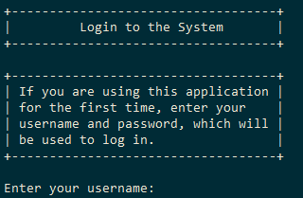

Description: Allows an existing user to access their account or register a new user with a username and password.

1. Login Prompt:

* The interface displays a greeting and instructions for first-time users, indicating that they should use their registered username and password to log in.

1. Username Input:

* Prompt: "Enter your username:"
* Input Requirement: User must enter their registered username. This field is typically a string without specific format restrictions unless defined by system policies.

1. Password Input:

* Prompt: "Enter your password:"
* Input Requirement: User must enter their password associated with the username. The password field is expected to be sensitive and treated confidentially, not displayed or stored in plain text.

1. Processing Login Attempt:

* Upon receiving the username and password, the system attempts to authenticate the user by comparing the entered credentials with those stored in the system’s database.
* If the credentials are correct, the system proceeds to log the user in, potentially updating session information and saving any necessary data.
* If the credentials are incorrect, the system informs the user and retries the login process by re-displaying the login prompts.

1. Feedback and Status:

* Successful Login: The system confirms the successful login and displays a message along with the username (the password is not displayed for security reasons).
* Failed Login: The system notifies the user of the failed attempt and provides an opportunity to try entering their credentials again.

### Main Menu

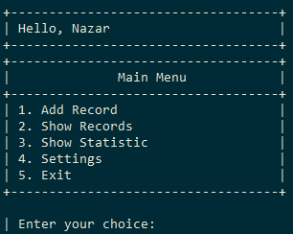

Description: provides user with the option to further interact with the program or exit it.

#### Add Record

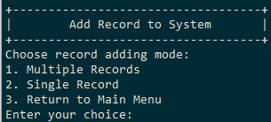

The user is presented with the following options:

1. Multiple Records: Allows the user to add multiple records at once.
2. Single Record: Enables the user to add a single record.
3. Return to Main Menu: Returns the user to the main menu.

Depending on the user's choice, further input methods are provided:

* In One Line: The user can enter all record details in a single line using a specific format.
* With Help Messages: The user is prompted for each piece of data one at a time, with guidance and validation at each step.

Input Requirements

Multiple Records or Single Record

* User Input: Numeric choice (1 for Multiple Records, 2 for Single Record, 3 to go back).
* Validation: Only valid integers corresponding to the menu options are accepted.

Choose Input Method

* User Input: Numeric choice (1 for In One Line, 2 for With Help Messages).
* Validation: Only the numbers 1 or 2 are accepted.

Data Entry Formats

Adding Records in One Line

* Format: amount,description,date[dd mm yyyy hh mm],category,type
* Example: 100.00,Lunch,12 03 2024 12 00,Food,Expense
* Fields:
* Amount: Numeric value (can be negative for expenses or positive for income).
* Description: Text description of the record.
* Date: Date and time in dd mm yyyy hh mm format.
* Category: The category of the record (e.g., Food, Utilities).
* Type: Either Income or Expense.

Adding Records with Prompts

Each field is input separately with the following prompts:

* Amount: Prompted to enter a numeric value. Validation ensures the value is a valid number.
* Description: Textual description, non-empty validation.
* Date and Time: Entered as dd mm yyyy hh mm and validated for correct date format and logical values.
* Category: Category name is entered, and if it does not exist, it can be created.
* Type: Prompted to choose between Income or Expense.

### Show Records

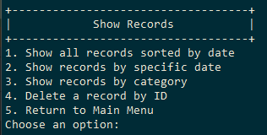

The user is presented with the following options:

1. Show all records sorted by date: Displays all records in the system, sorted by date.
2. Show records by specific date: Filters and shows records from a specific date.
3. Show records by category: Filters and shows records that match a specific category.
4. Delete a record by ID: Allows you to delete a specific record by entering its unique ID.
5. Return to Main Menu: Exits the record show menu and returns to the main application menu.

Input Requirements and Process Flow

Choosing an Option:

* User Input: A single integer (1-5) to select an option.
* Validation: Only integers corresponding to the menu options are accepted. If an invalid option is entered, the system prompts the user again.

Option-Specific Details:

1. Show All Records Sorted by Date

* Displays all records, paginated, with navigation options to view next or previous pages or return to the menu.

1. Show Records by Specific Date

* Input Requirement: Date in the format dd mm yyyy.
* Process: The user is prompted to enter a date. The system converts the input into a DateAndTime object and displays records from that date, paginated similarly to option 1.

1. Show Records by Category

* Input Requirement: Category name as a string.
* Process: After entering a category name, the system displays records matching that category, also with pagination.

1. Delete a Record by ID

* Input Requirement: Record ID as a long integer.
* Process: The user is asked to enter the ID of the record they wish to delete. If the ID exists, the record is deleted and confirmation is provided; otherwise, an error message is displayed.

1. Return to Main Menu

* Process: Immediately exits the record display and management interface and returns to the main menu.

Pagination Commands

When viewing records (options 1, 2, and 3), the user can navigate through pages using the following commands:

* n: Next page.
* p: Previous page (if not on the first page).
* b: Back to the main records menu.

### Show Statistic

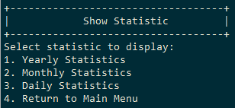

The user is presented with the following options:

1. Yearly Statistics: View financial statistics aggregated on a yearly basis.
2. Monthly Statistics: View financial statistics aggregated on a monthly basis for a specified year.
3. Daily Statistics: View financial statistics aggregated on a daily basis for a specified month and year.
4. Return to Main Menu: Exit the statistics viewing interface and return to the main menu of the application.

Detailed Description of Each Option

1. Yearly Statistics

* Process: Upon selection, the system retrieves and displays statistics for each year, showing income, expenses, and profitability.
* Visualization: Each statistic is represented in a graphical format, where the length of each bar corresponds to the value of the statistic.
* No additional input required after selecting this option.

1. Monthly Statistics

* Input Requirements:
* Year: You need to enter the year for which you want to view statistics in the format yyyy (e.g., 2022).
* Process: After entering a valid year, the system retrieves and displays statistics for each month of the specified year.
* Visualization: Similar to yearly statistics, monthly values are also displayed graphically.

1. Daily Statistics

* Input Requirements:
* Year: Enter the year in the format yyyy.
* Month: After entering the year, you will need to enter the month in the format mm (e.g., 07 for July).
* Process: Once the year and month are specified, daily statistics for that month are retrieved and displayed.
* Visualization: Daily statistics are presented graphically, showing income, expenses, and profitability for each day.

4. Return to Main Menu

* Process: Simply returns you to the main menu of the application.

### Settings

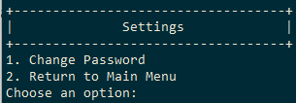

The user is presented with the following options:

1. Change Password: Allows the user to update their password.
2. Return to Main Menu: Exits the settings menu and returns the user to the main menu of the application.

Detailed Description of Each Option

1. Change Password

* Process:
* The user is first prompted to enter their current password. If the current password is validated successfully against the stored value, the user proceeds to the next step.
* Next, the user is asked to enter a new password.
* If the new password is valid (non-empty and potentially meeting other unstated criteria like length or complexity), it is set as the user's new password.
* Input Requirements:
* Current Password: You need to enter your existing password to authenticate the request for change.
* New Password: You are required to input a new password, which should ideally meet any predefined security standards (not specified in the code provided).

1. Return to Main Menu

* Process: Simply returns you to the main menu of the application.
* No additional input is required after selecting this option.